**NAAN MUDHALVAN DIGITAL MARKETING ASSIGNMENT**

AU913120104056 – Monisha KB

# LINKEDIN CREATION:

Visit LinkedIn: Go to LinkedIn's website at [www.linkedin.com.](http://www.linkedin.com/)

Sign Up: On the LinkedIn homepage, you'll see a "Join now" or "Sign up" option. Click on it.

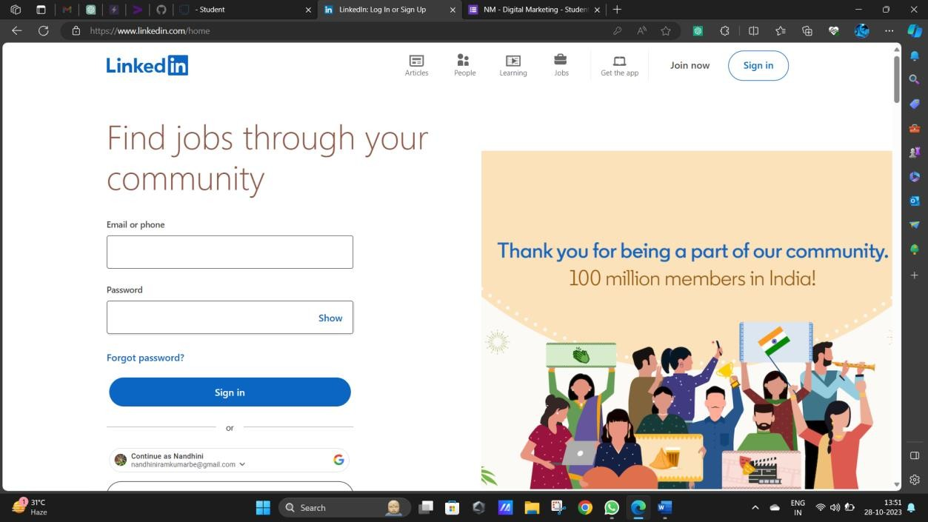

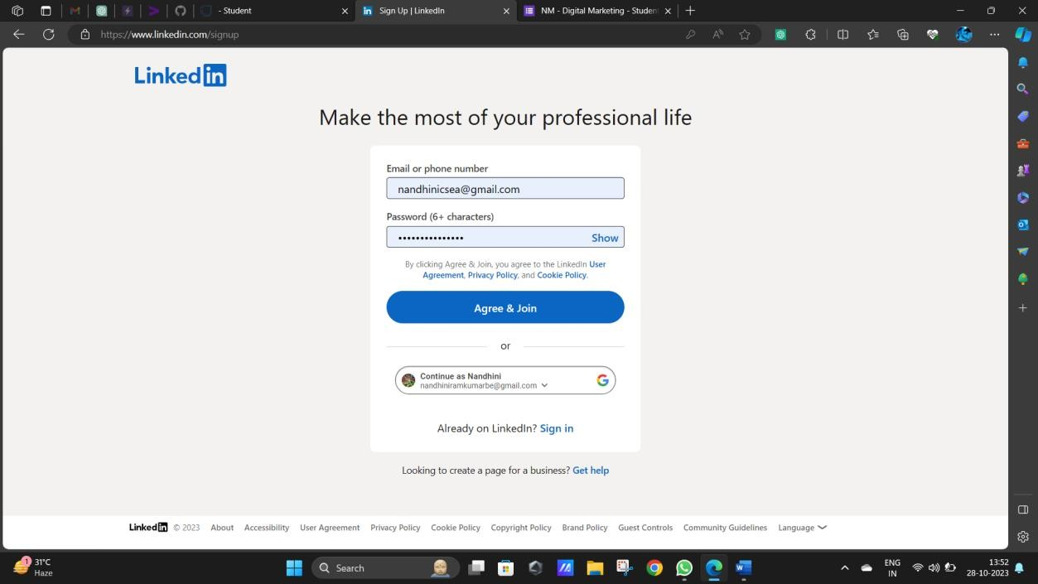

Provide information and complete profile

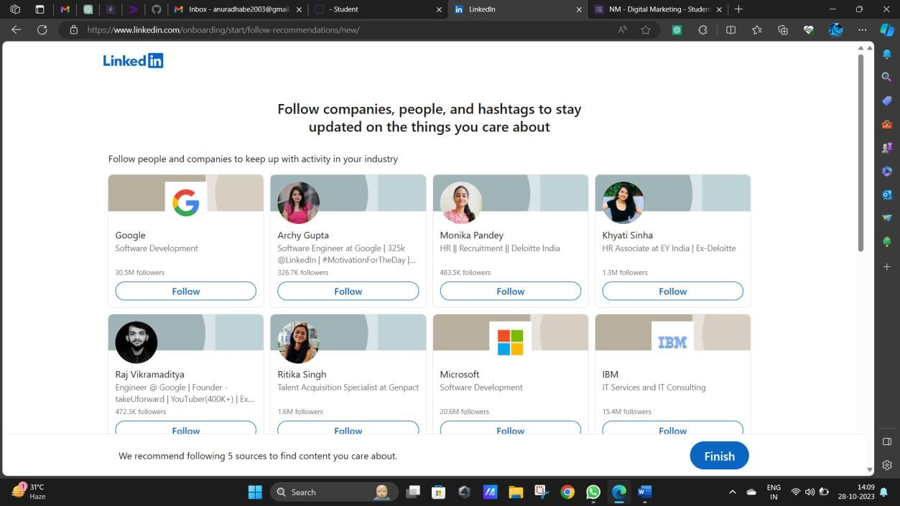

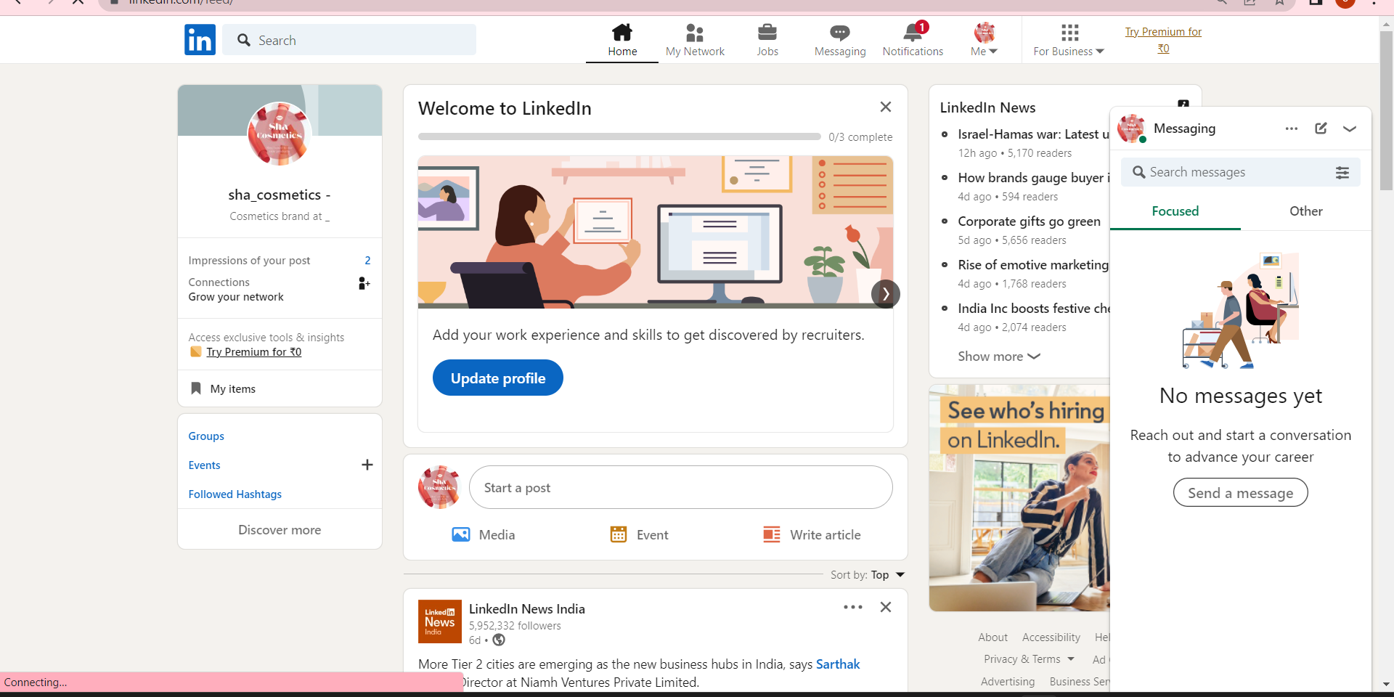

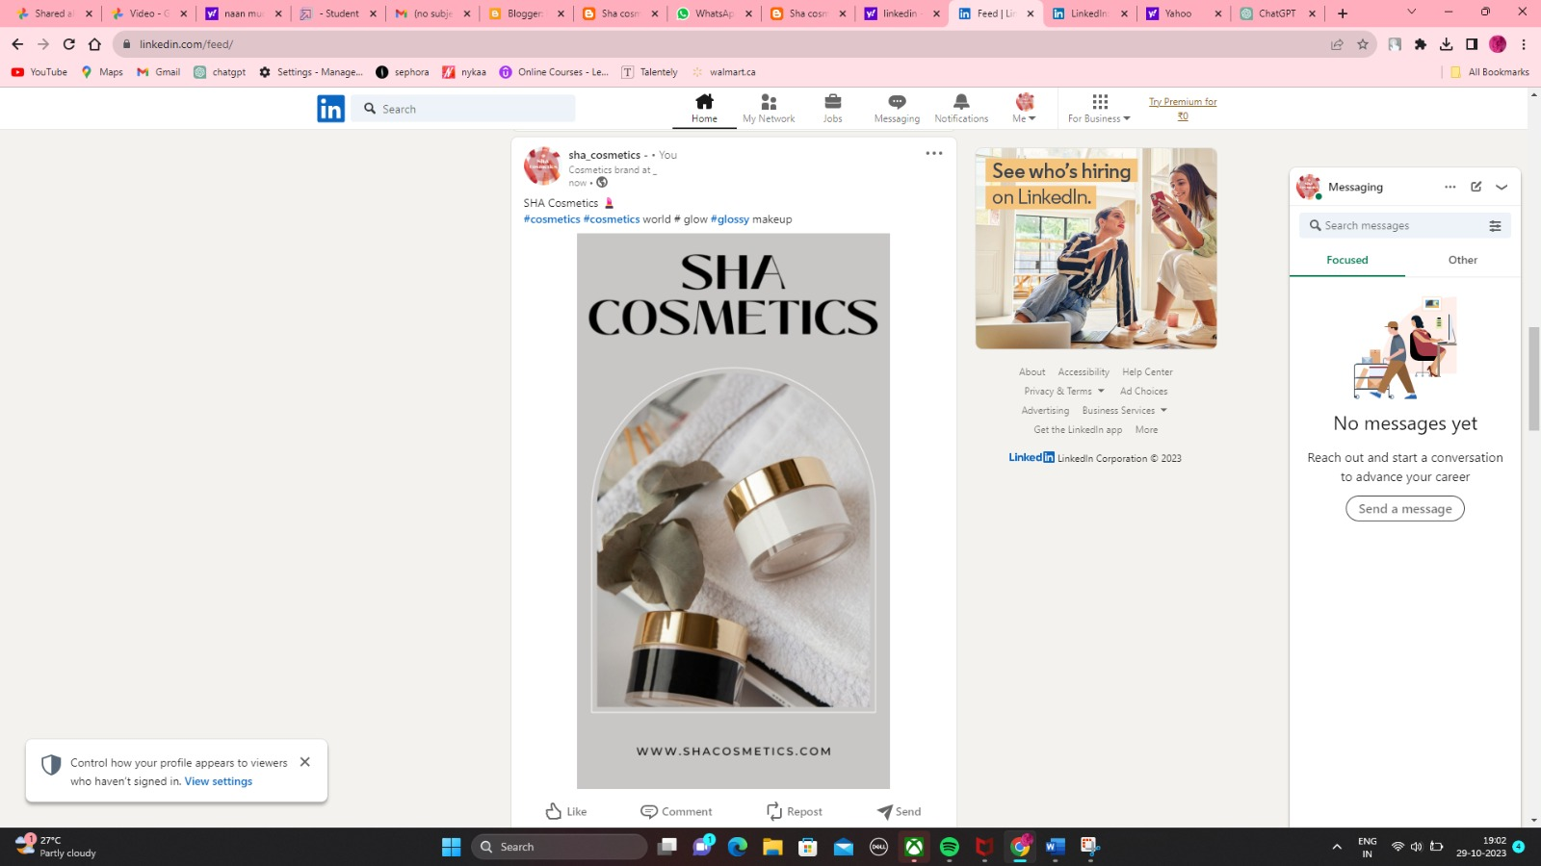

**BRAND NAME: SHA COSMETICS**



**CREATION OF BLOG PAGE:**

**BLOG URL:** [**https://sushmoni.blogspot.com/2023/09/**](https://sushmoni.blogspot.com/2023/09/)

Creation of a blog page starts with providing details and the page is created, then selecting the Layout for a good look on the user side.

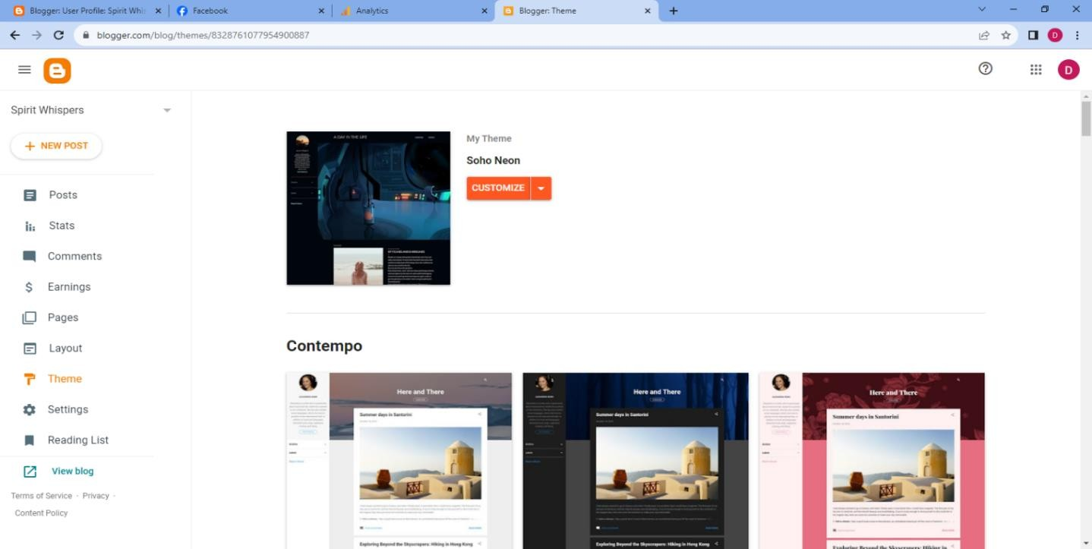

Then provide the details required for the profile on the page

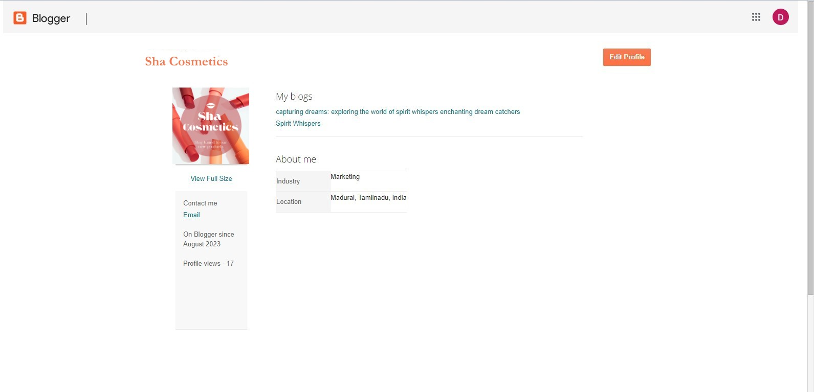

Then the blog home page is created for Sha Cosmetics.

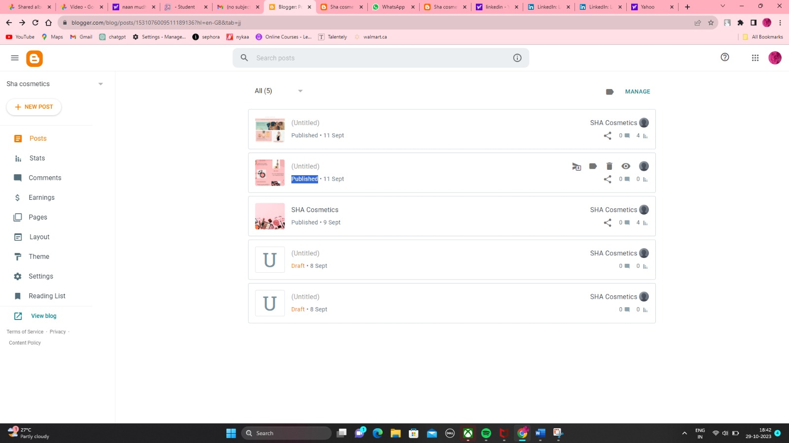

Then add posts and further information that describes sha cosmetics. Sha Cosmetics is a specialized online platform, that focuses on various aspects of beauty, makeup, skincare, and personal grooming and other services to reach the client.

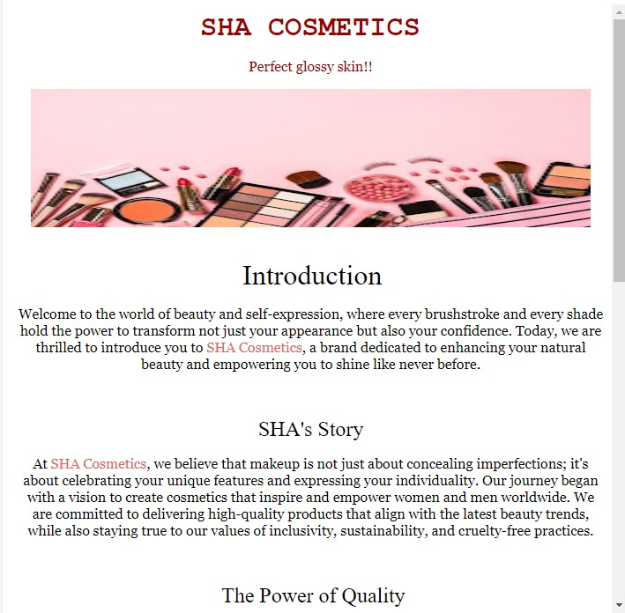

Be more specific of the information and be true of the information that has been provided.

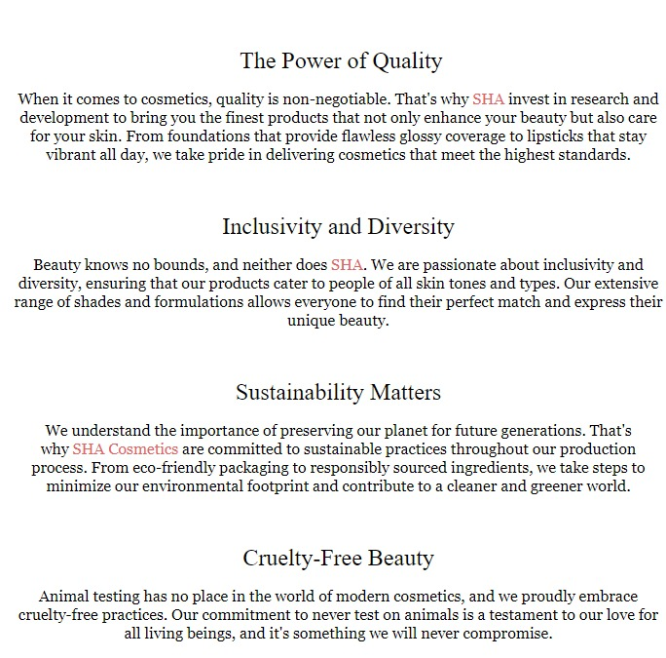

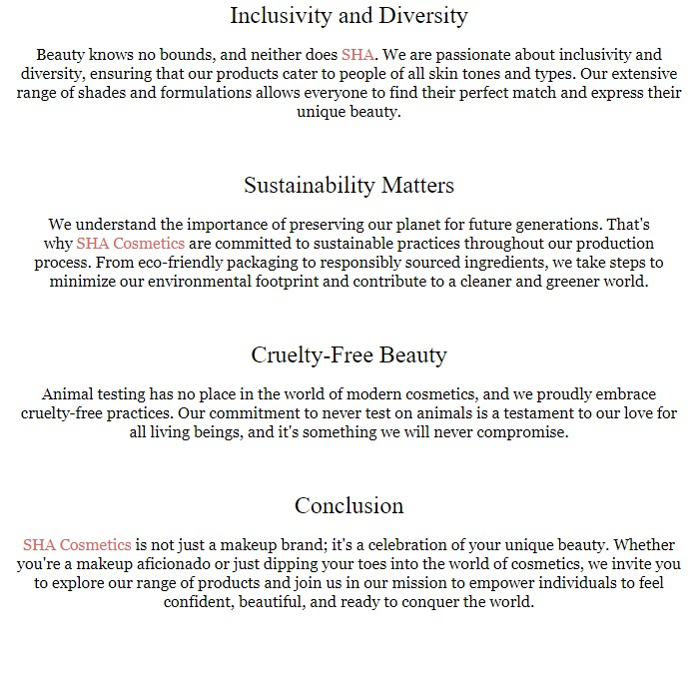

After completing the post save it and publish.

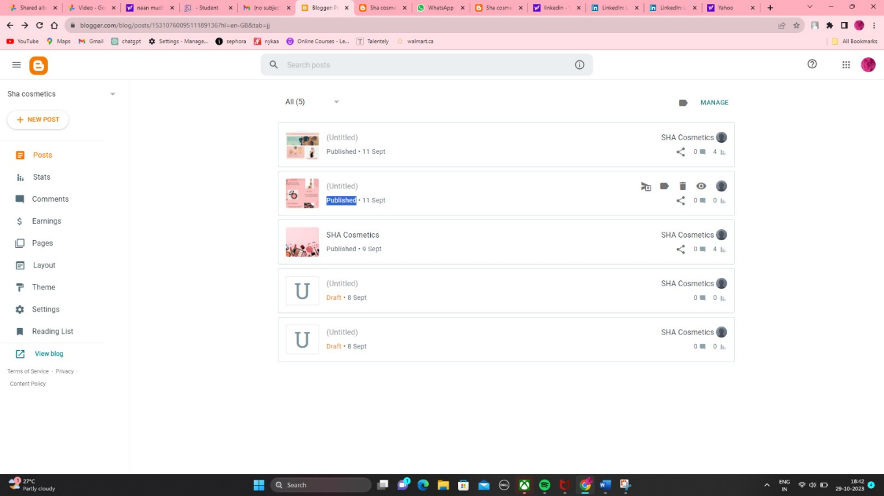

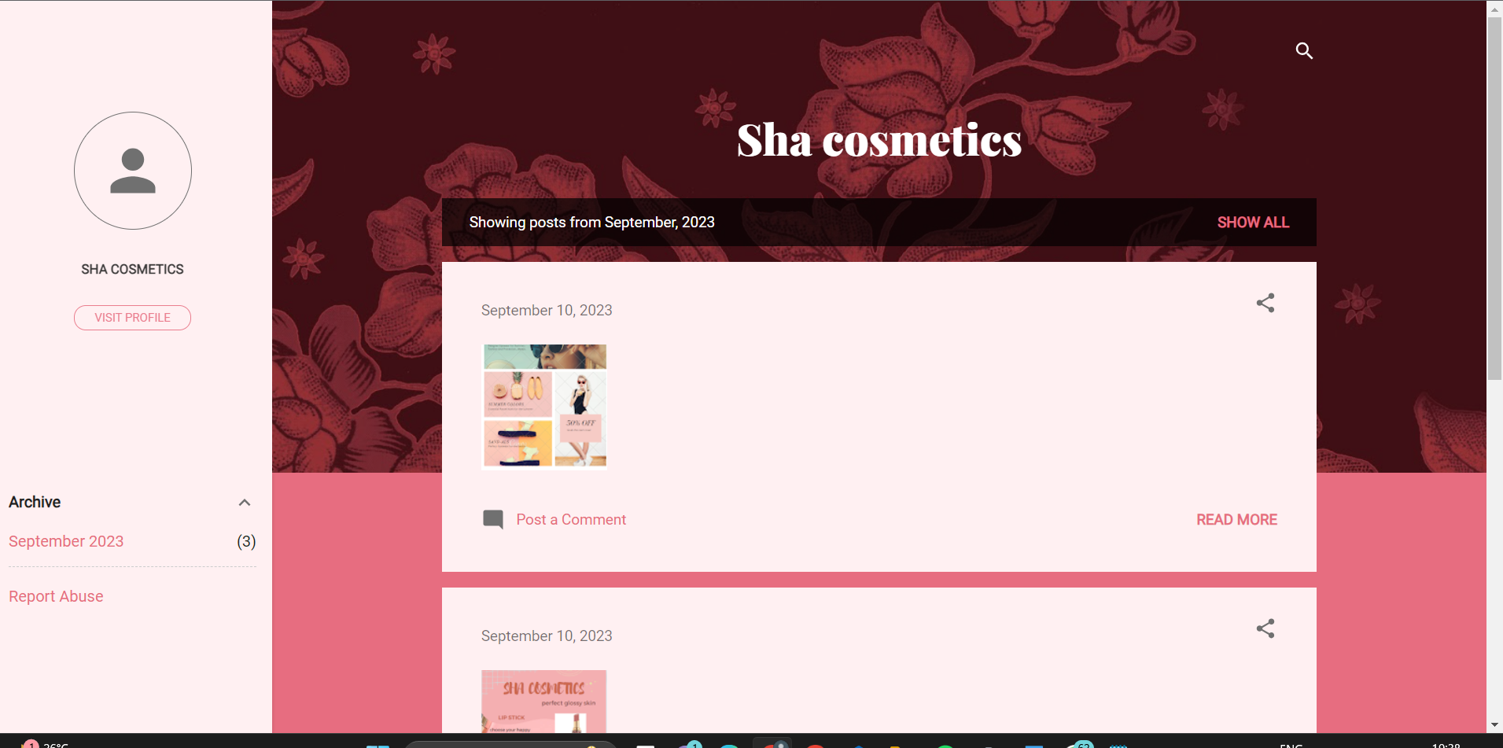

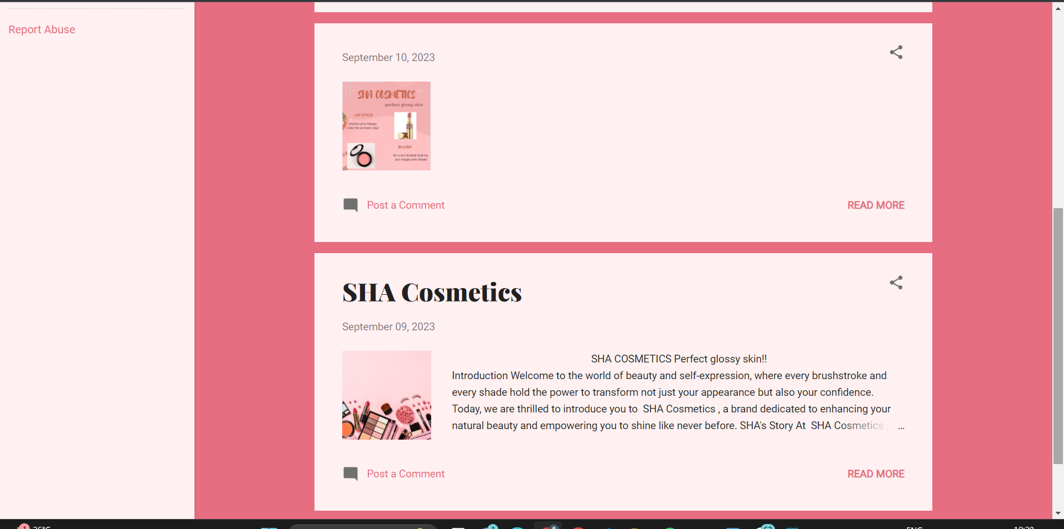

**FACEBOOK URL:**

[**https://www.facebook.com/profile.php?id=61550674348114**](https://www.facebook.com/profile.php?id=61550674348114)

Creation of a Facebook business page for Sha Cosmetics an online platform, that focuses on various aspects of beauty and makeup. A business profile is created by entering the required details.

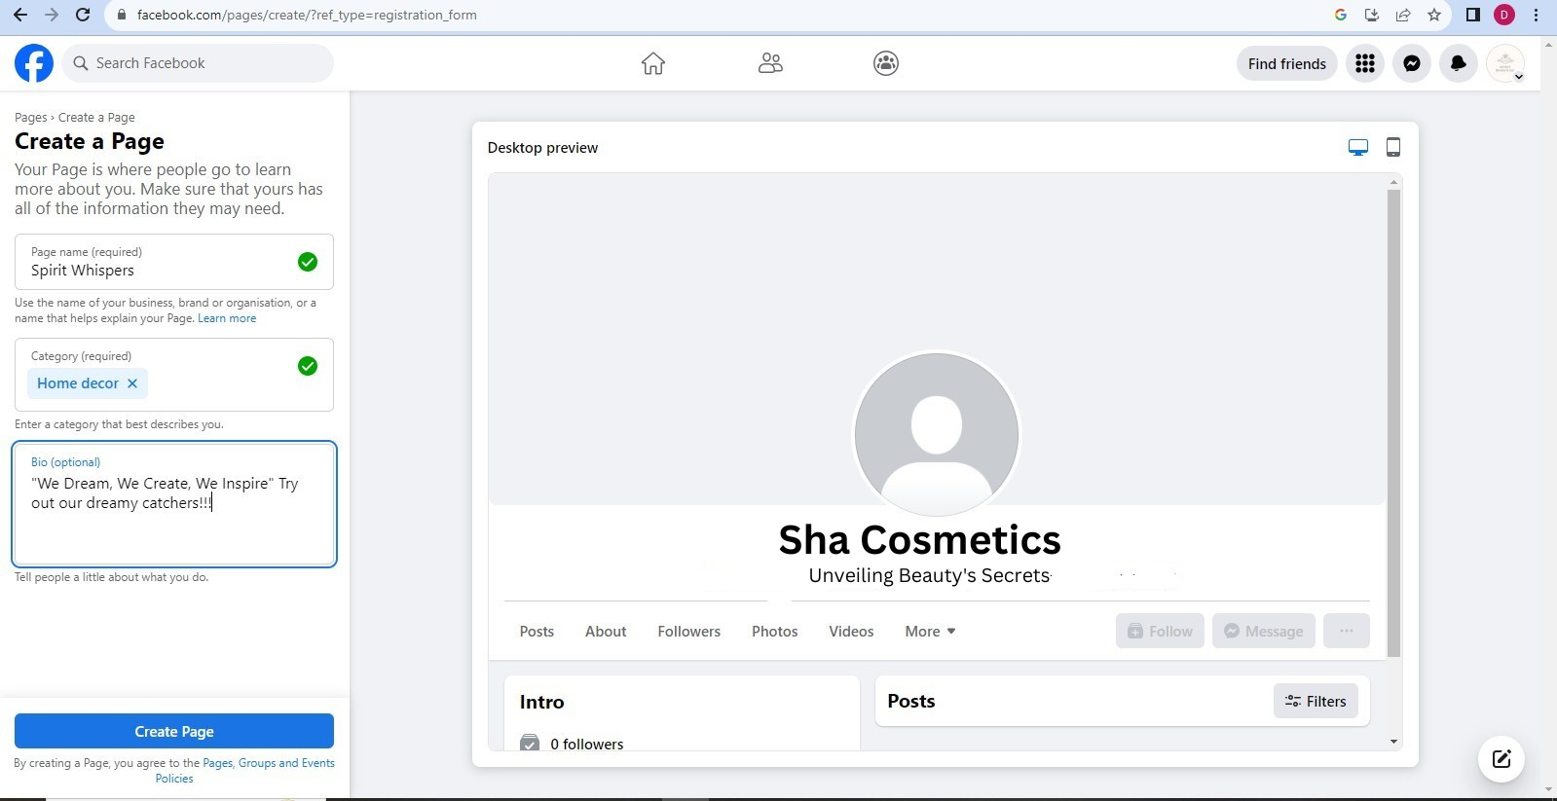

Add cover photos.

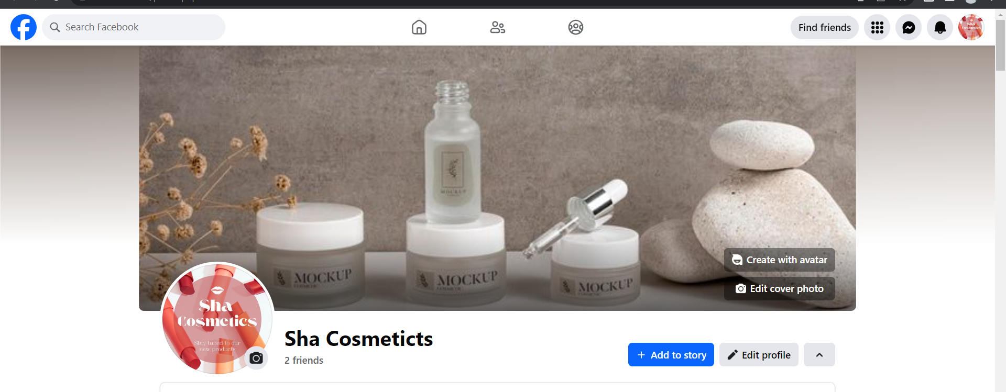

Add some posts to enhance the brand.

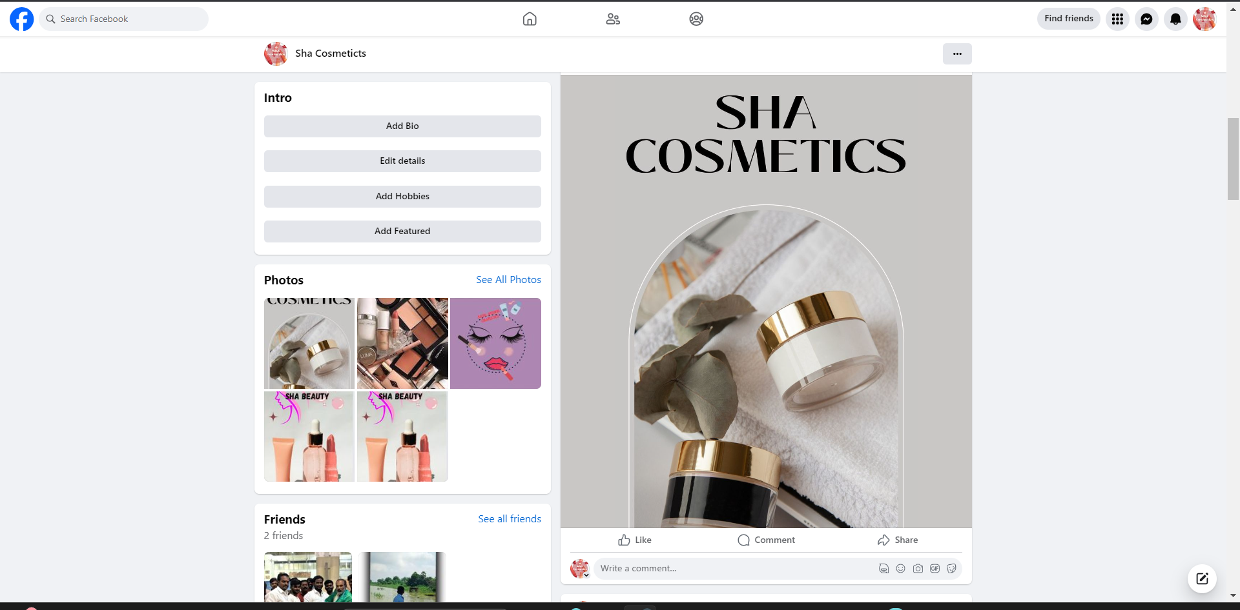

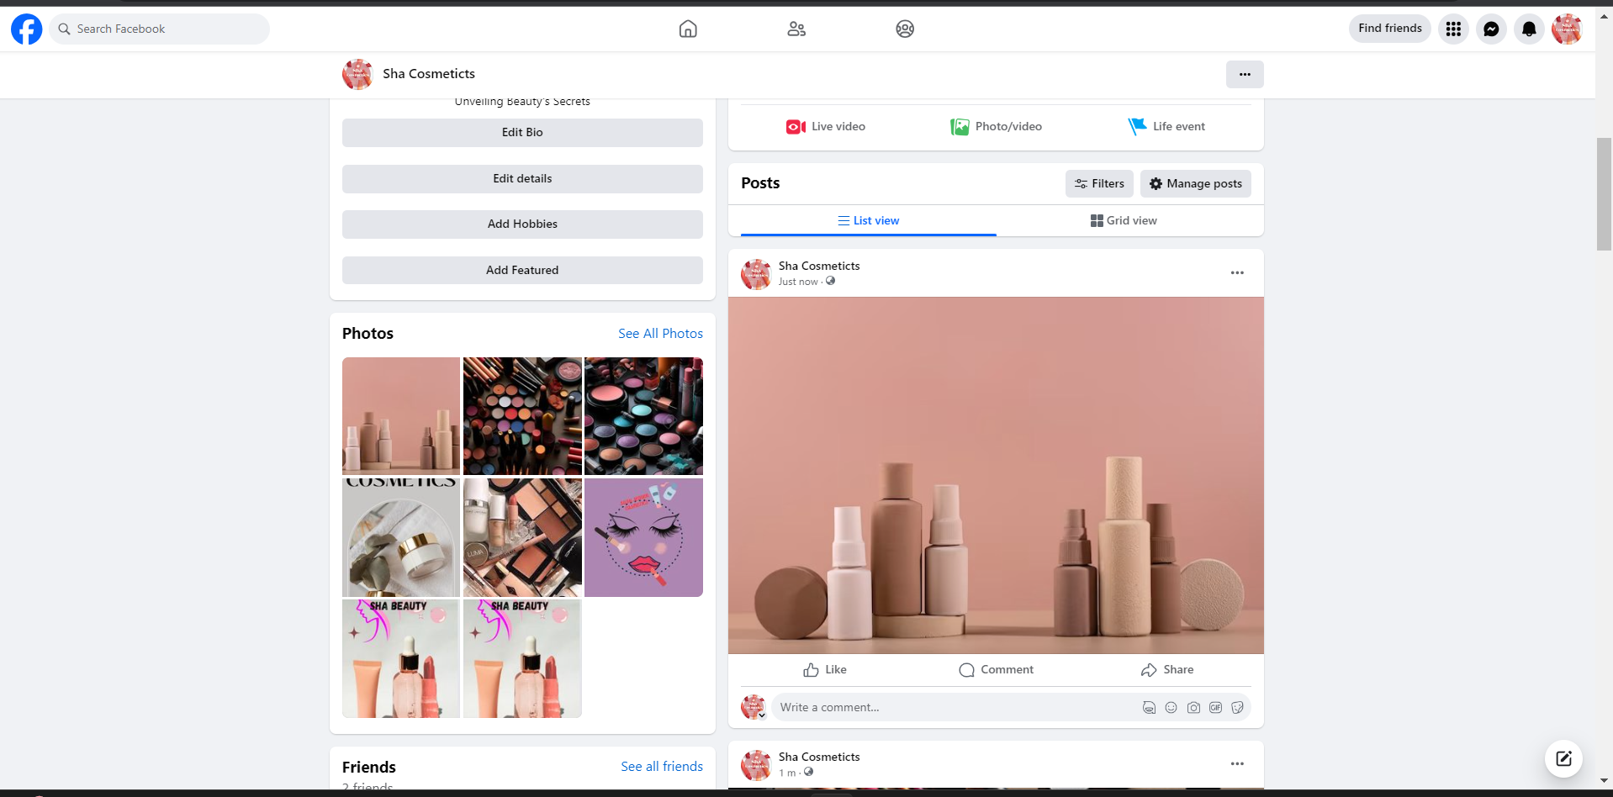

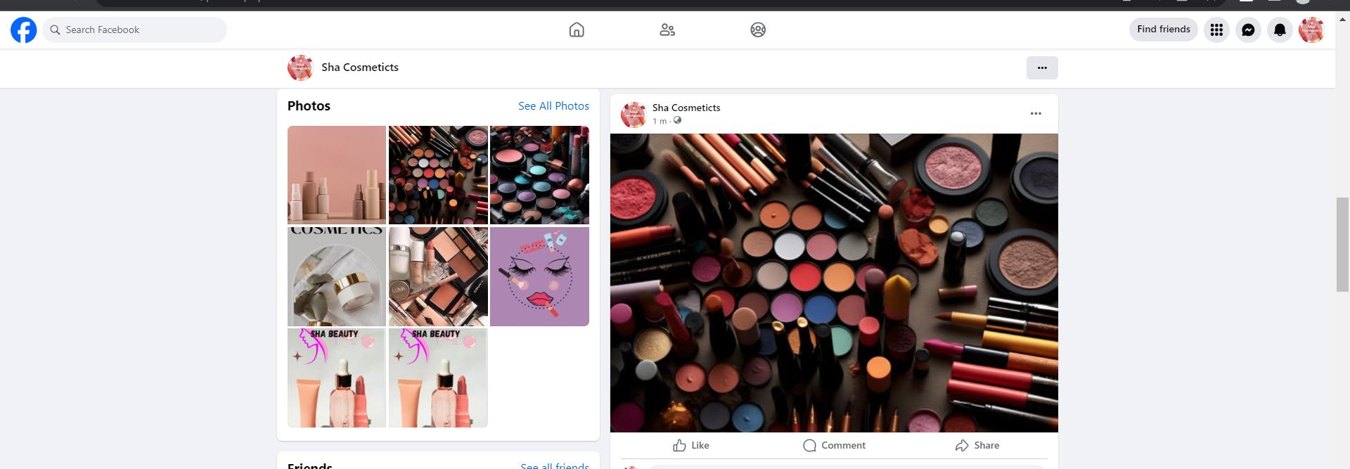

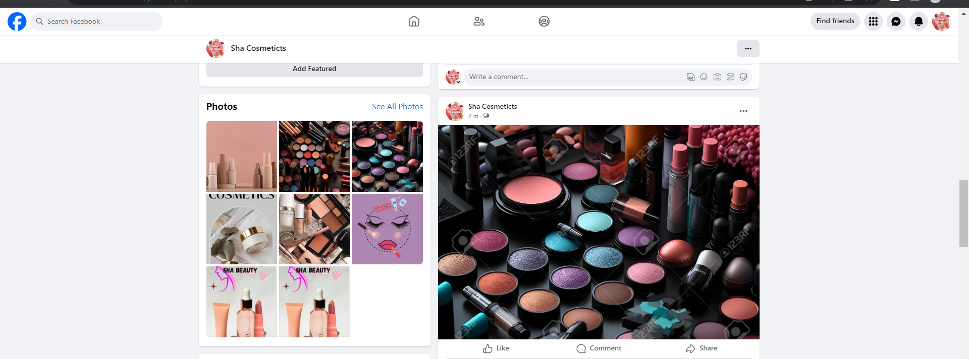

**EMAIL NEWSLETTER POST: - Blog URL:**

[**https://sushmoni.blogspot.com/2023/09/sha-cosmetics.html**](https://sushmoni.blogspot.com/2023/09/sha-cosmetics.html)

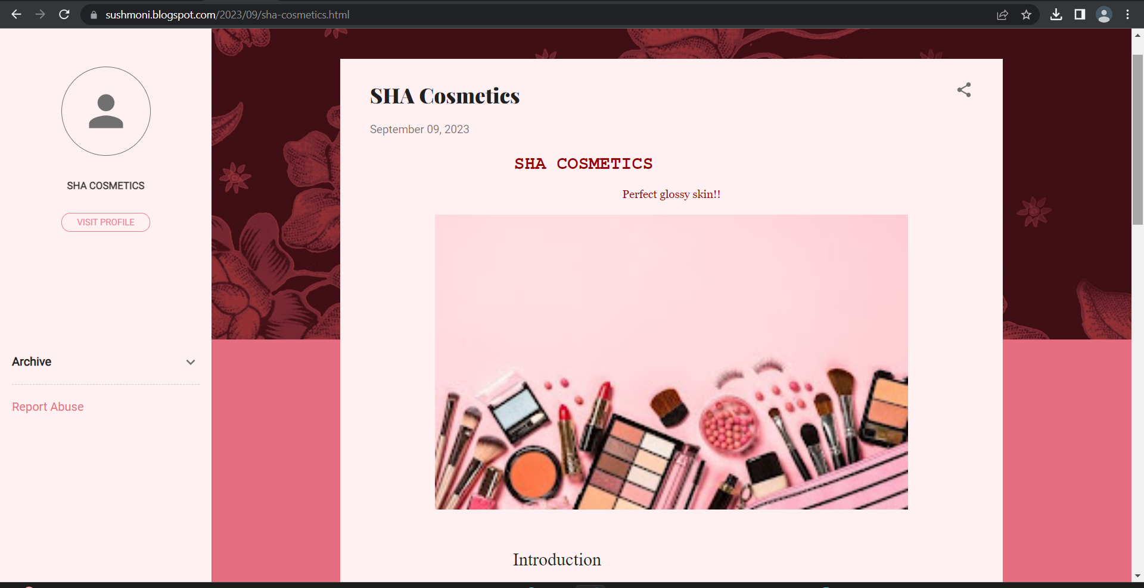

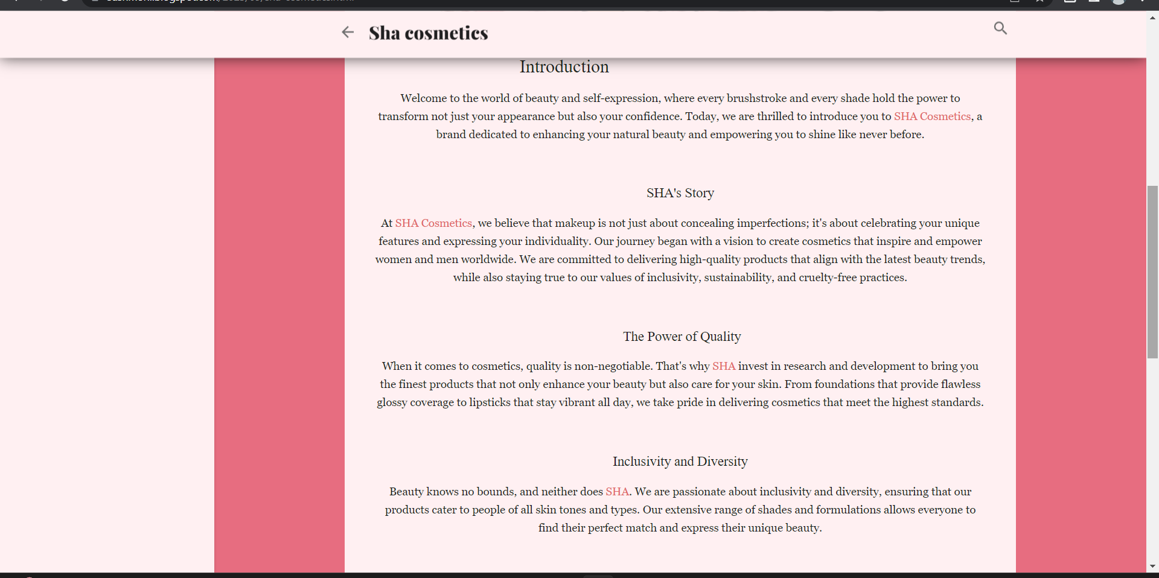

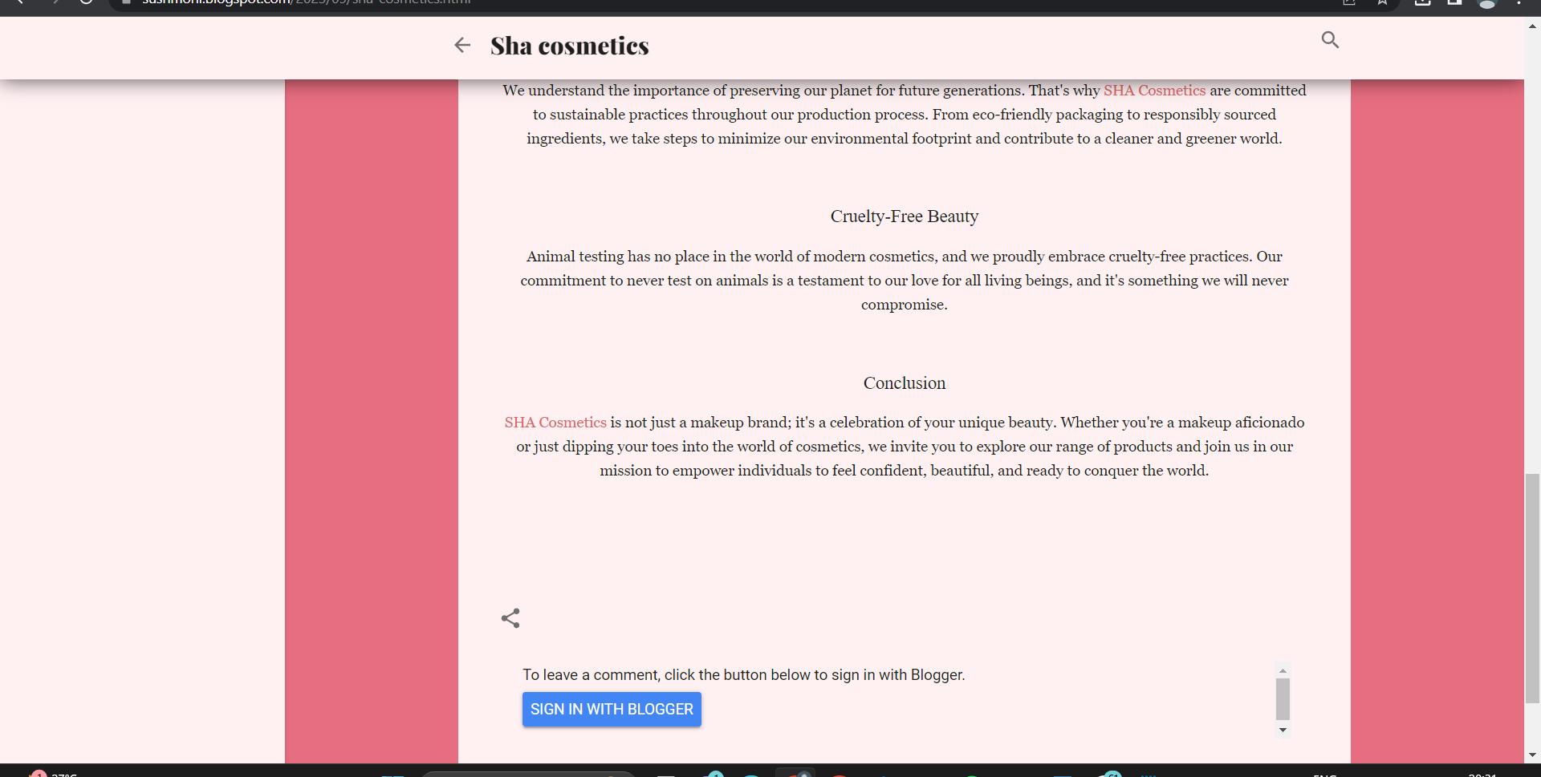

**INFOGRAPHIC POSTER- Blog URL:**

[**https://sushmoni.blogspot.com/2023/09/blog-post.html**](https://sushmoni.blogspot.com/2023/09/blog-post.html)

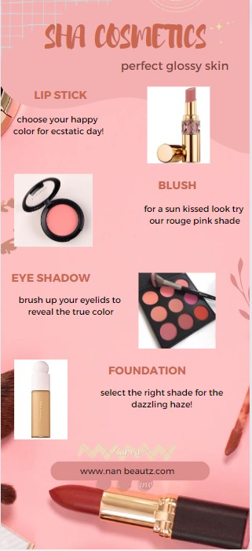

**GOOGLE ANALYTIC MEASUREMENT ID:**

Google analytic measurement ID: G-4TQ3TNNX0V

Visit Google Analytic official page.

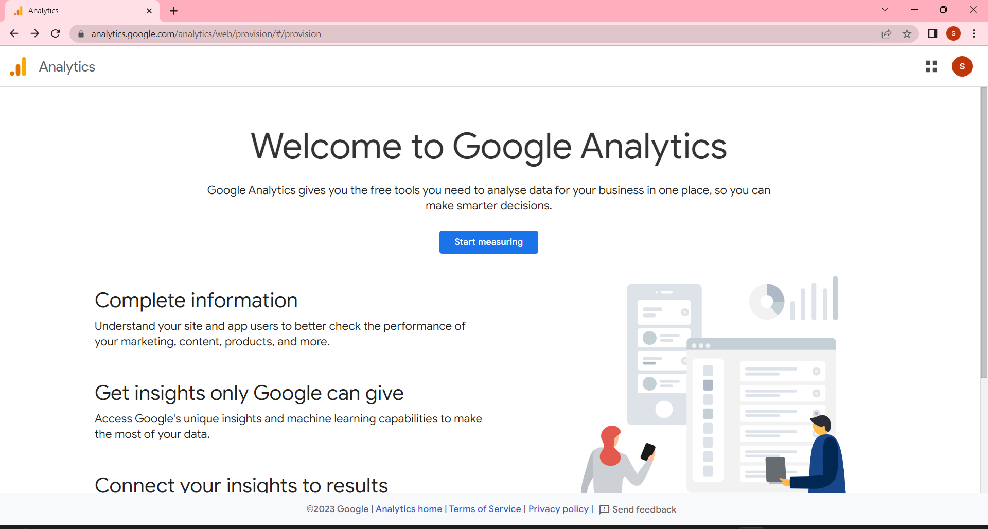

Create an account by means of enter details.

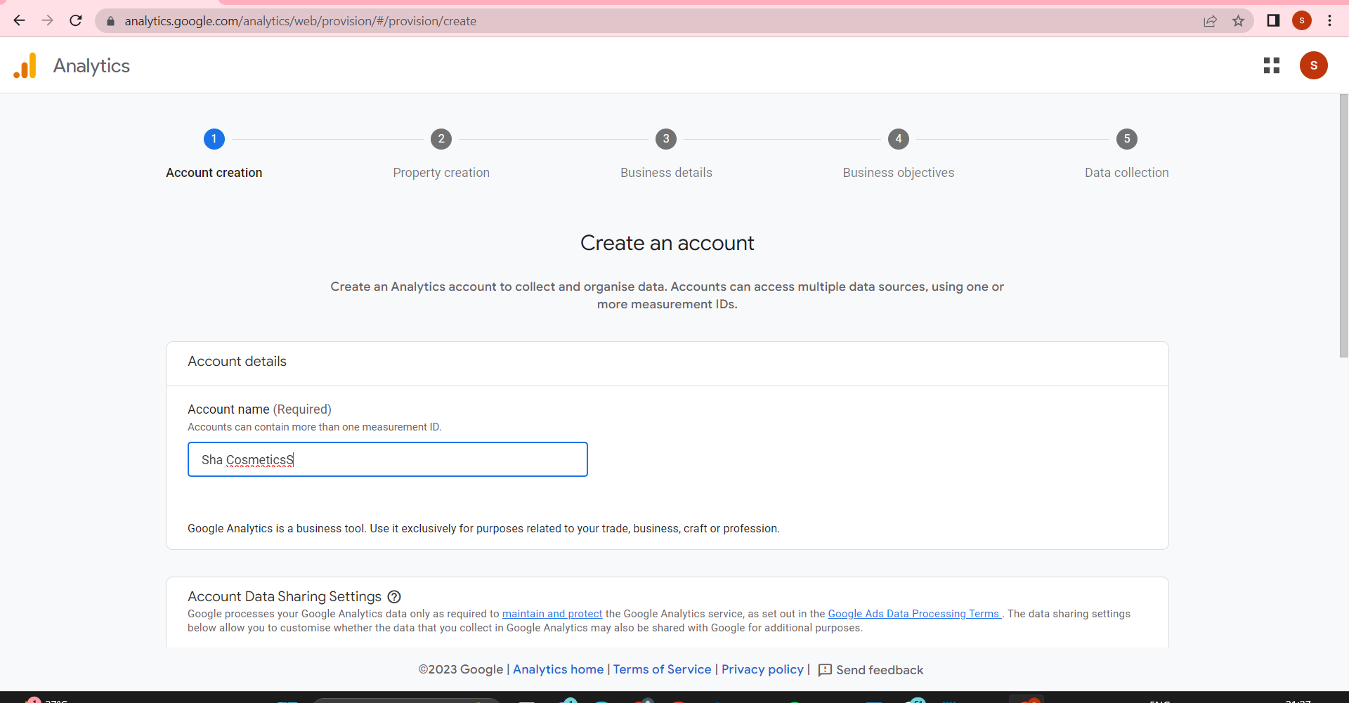

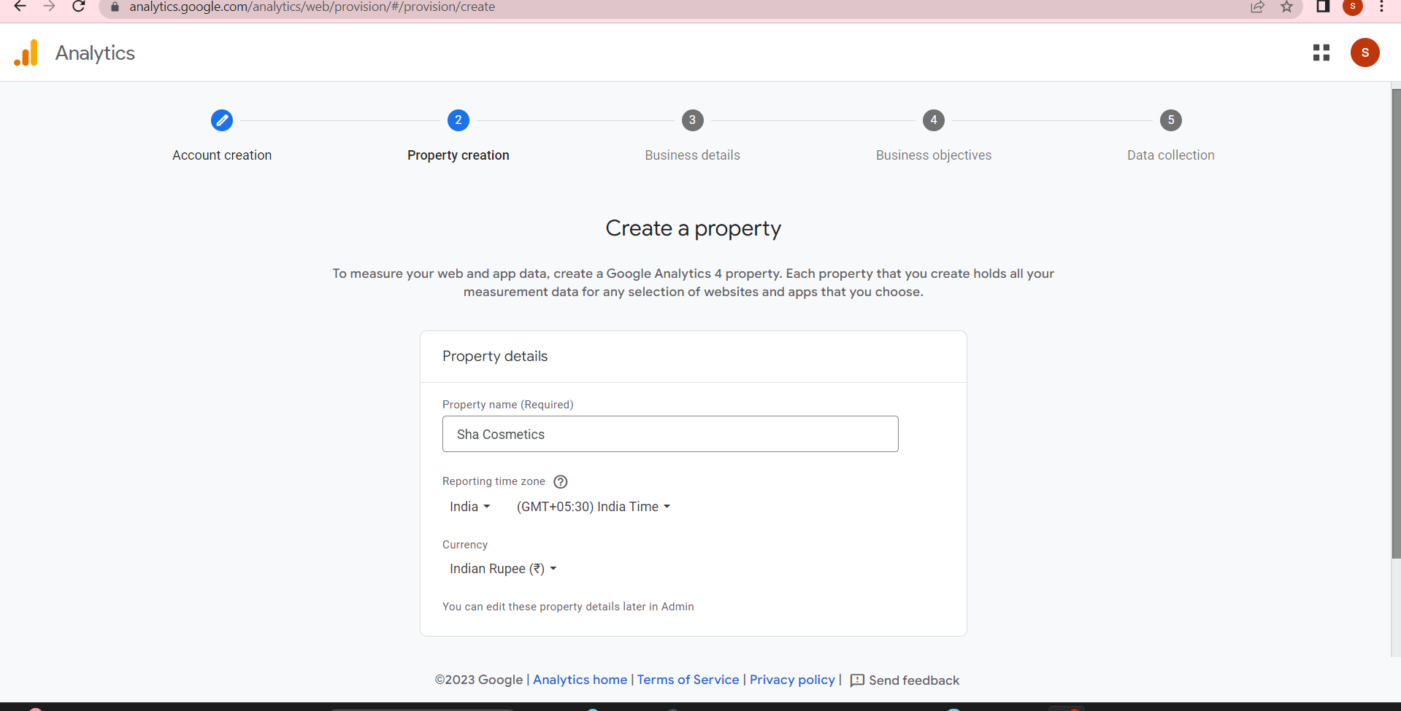

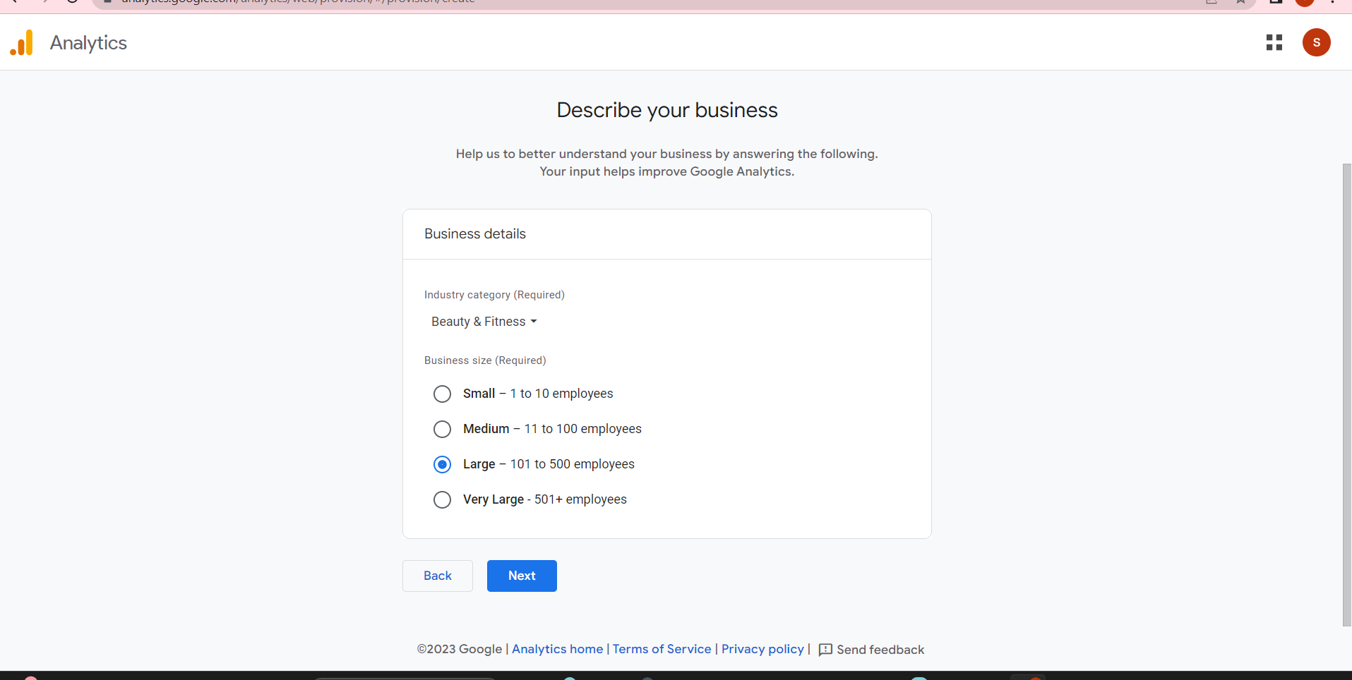

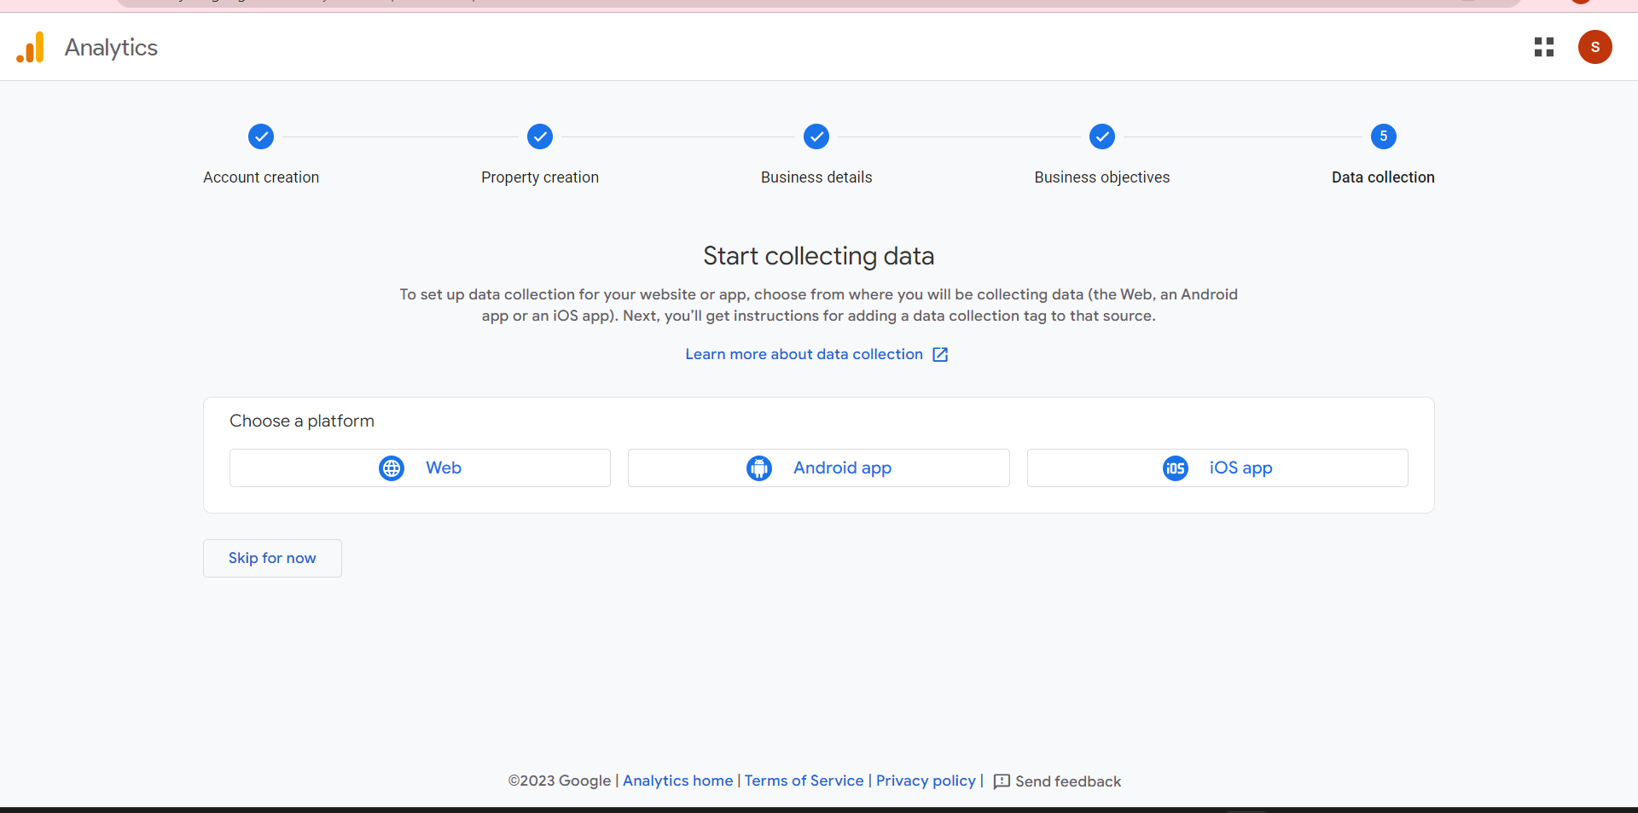

Then click Web to create a Stream.

